NSS State Level Award

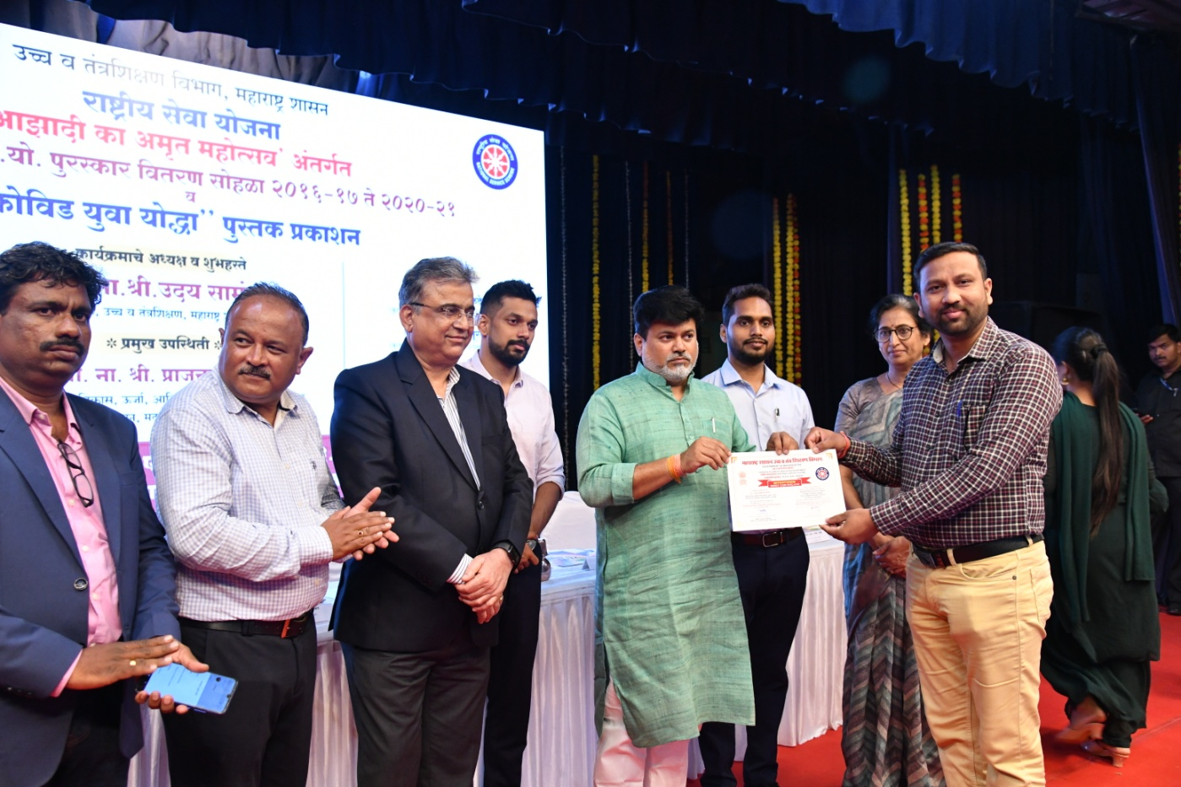

Prof Anup Sayare awared by Outstanding Program Officer Appreciation Certificate

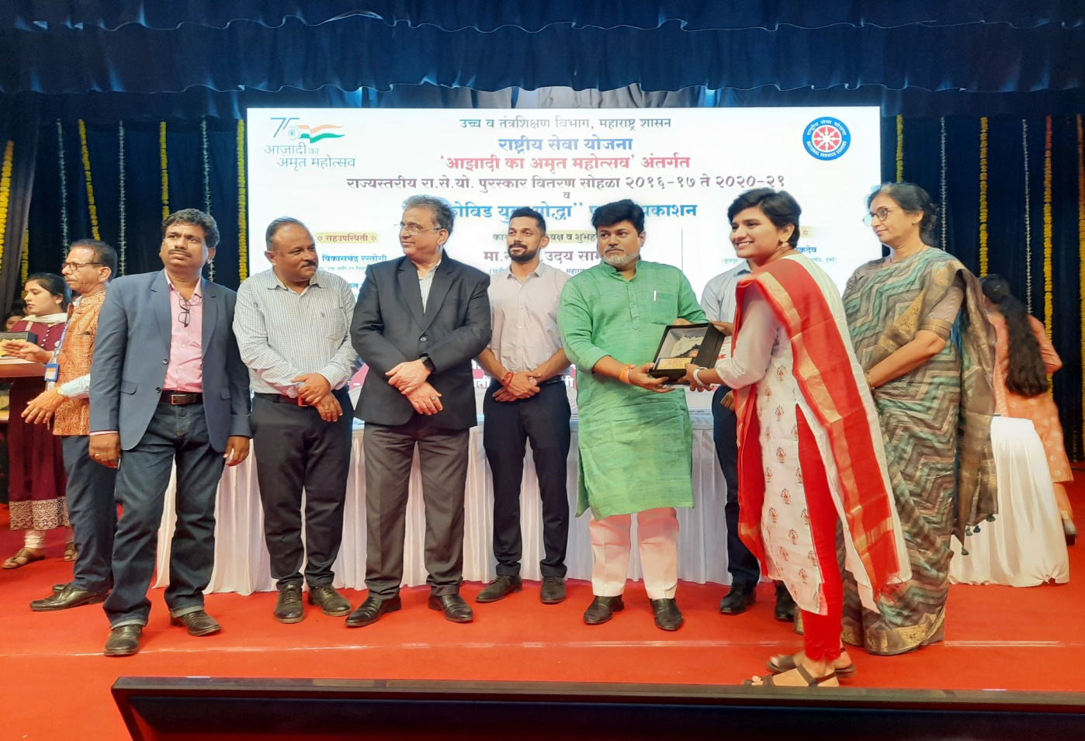

Miss Renuka Mirge awared by Outstanding Student Voolunteer.